SR20DET & Gearbox Fitting Guide for LHD European S13 200sx

John Bennett
Additional research: Marty_T3 and Fry1

This document considers donor engines from the LHD 200sx S13, S14 and the S15.
It assumes you are experienced in engine removal and fitting, concentrating on the main ‘difficulty’ – electrical wiring. At the back of this document a more detailed mechanical fitting guide is included by Fry1.
The air-pipe plumbing system is not considered in detail, as factory service manuals show this for you, and it is open to re-arranging anyway (aftermarket FMIC’s etc).
I take no responsibility for you blowing up your ECU/engine etc due to errors in this document, or your own cack-handedness. This is just a guide, read the service manuals if you’re not sure (that’s where I got all the info from).

Engine/Mechanical Fitting Overview

S14 & S14a

- Straight fit on engine mounts and gearbox.
- Use original S13 propshaft.
- Speedometer may require speed sender from S13 box to operate correctly
- Throttle cable to plenum mount sits further forwards than CA18 so fixing cable is not possible, - use either SR20 throttle cable, or alter/recreate a new mount.
- Wing Intercooler can be used as a temporary solution. IC Pipes may need to be crossed over.
- Exhaust will not fit. Custom, or combine S14 downpipe, decat pipe and S13 rear.

Wiring Guide

Fitting an SR20 should have no effect on the ABS system (in UK cars), but this has not been verified yet (all cars tested didn’t have ABS), so if you get an ABS warning light flashing, please contact me.

Remove the starter/alternator/gearbox loom from your CA18DET.
Fit it to your SR20DET. This is shown below.

All the starter/alternator/oil pressure plugs should be a straight fit, except for the alternator ring terminal for which you may need to enlarge the hole with a circular file.

I don’t know if the 3 gearbox connectors (reverse, neutral and speedometer) are the same for SR and CA 5-speed boxes. If they don’t fit, cut the CA18 gearbox plugs off and solder on the SR20 plugs. Also, remove the gearbox speed sender from the CA18 gearbox (1 bolt, and twist it out) and fit it to the SR20 gearbox.

The S15 6-speed box definitely has different plugs for neutral and reverse sensors, so I attached them to the wires of the corresponding plugs on the CA18 gearbox loom. The 6-speed has no speed sensor (contact me, as I can provide a circuit board to obtain a speed signal from the rear ABS sensor).

If your S13 loom is dirty or untidy, remove the black tape (keep the plastic sleeves though), and wash it in soapy water, then dry and re-tape it.

Your SR loom may be newer looking, but using the CA starter/alternator/gearbox loom allows you to plug it straight back into the S13 engine bay connectors without any serious rewiring or plug swapping.
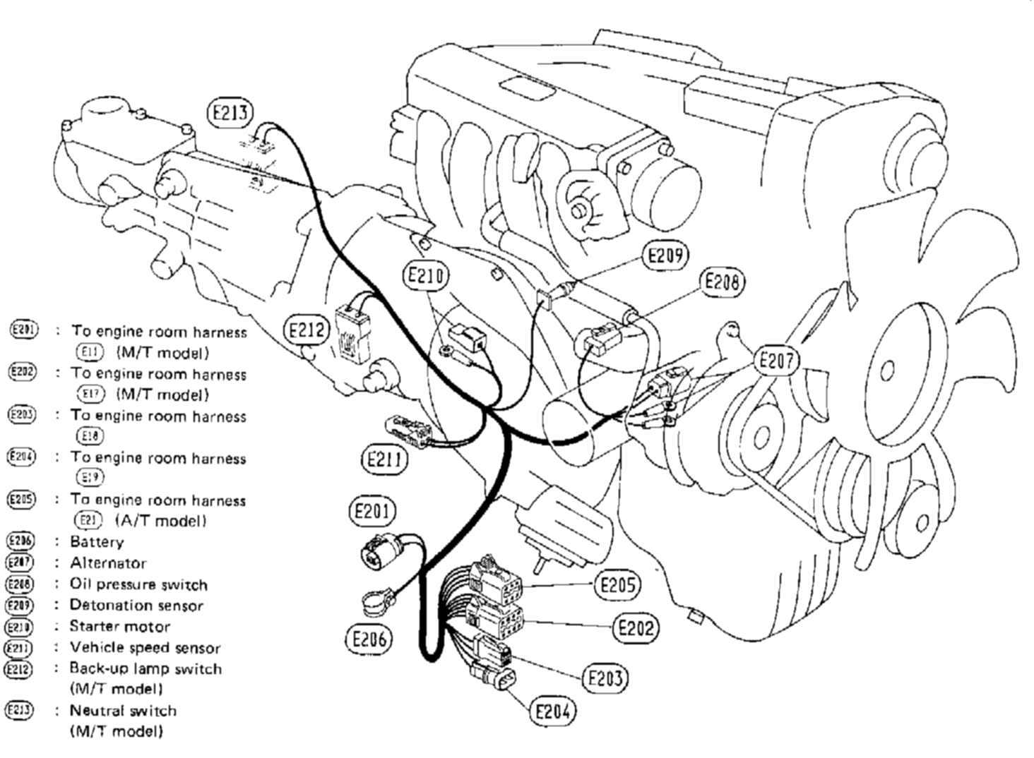
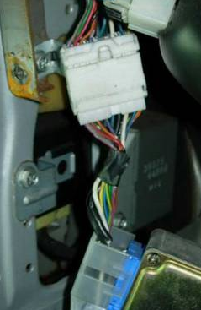
Take your S13 main engine loom (the one with the ECU on one end – see below).
There are 3 plugs (F8, F9 and F10) that go to sockets by the fuse box.

Connector F1

These sockets provide power to the ECU, as well as the signals from the gearbox.
You need to extract the 3 plugs from the harness along with their wires, as they are going to be re-attached to the SR20 main loom to provide power for the new ECU.
Extract the wires as far back as you can (to within 20cm of the ECU connector, if possible).
This will involve removing lots of tape, and cutting any wires that branch off to other parts of the loom (don’t worry about the ECU connector (F2), you don’t need it).

An alternative would be so just cut off F8, F9 and F10 and solder on a couple of meters of wire to each pin, but I didn’t want my CA18 loom and I couldn’t be bothered to source and join more wire.

Also there’s a plug (F1) just next to the ECU connector (see right). Cut this off, leaving about 5cm of wire. You will later attach this plug to the SR20 loom too. This provides 4 connections (start signal, speedo, tacho and water temperature).
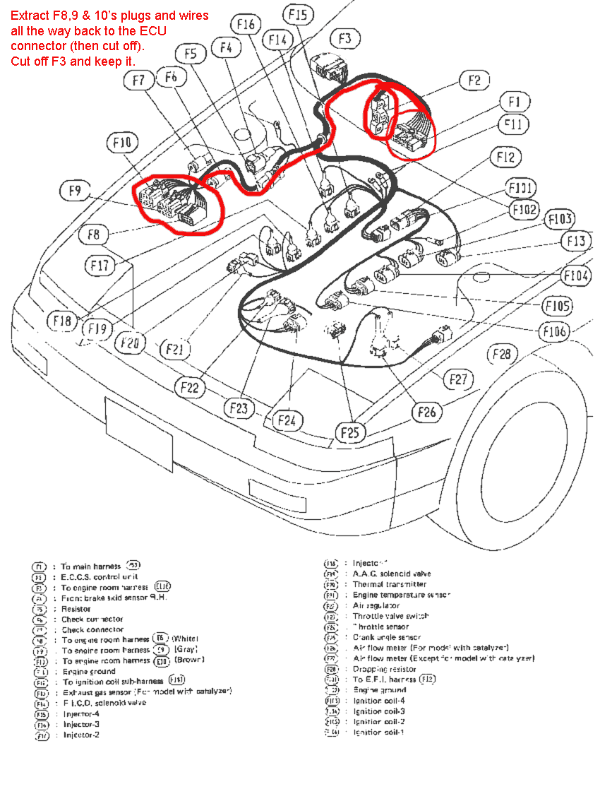

Ok, now you need to look at the main ECU loom of your SR20. Transfer all of this loom with the SR20 into your S13.
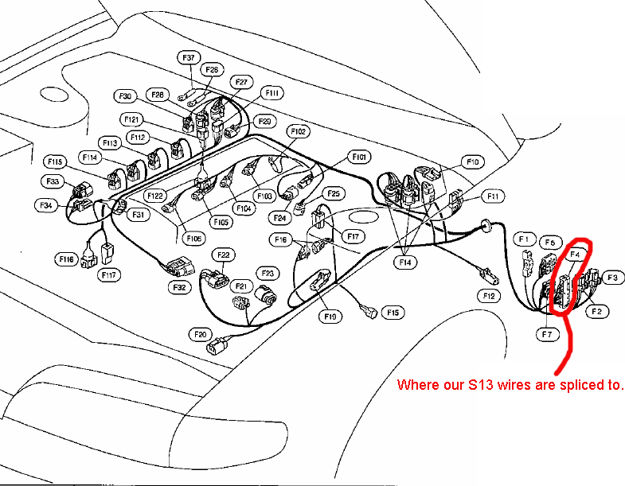
RHD SR20 donor engine:
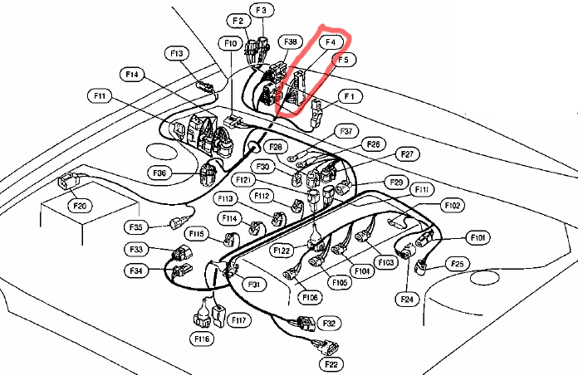
LHD SR20 donor engine.
I have indicated connector F4. This is where you will be joining wires to this loom, in order to fit it to the S13.
On the previous page, connector F4 is circled. It will look like the photograph below. All of the wires from the S13 to the SR20 will be joined at this connector.

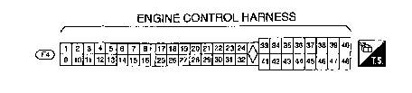

40
48

1
2

Pins 1 to 32 are the smaller pins on the grey side of the plug. The pin diagram is ‘Terminal Side’ – this is the numbering when you are viewing the pins/sockets. To be sure, Pin 40 is the thick black wire in the far left hand side of this photo,

Ideally, if you’re getting your SR20 from a scrap S14/S15 then try and get the corresponding interior connector to F4 (it is also white, with a grey lever on it)– slice it off a few cm from the connector and then you can join onto the wires. If you can’t get this connector, then you will have to join your wires directly to F4 (either strip them back and wrap the wire around in a ‘T’ arrangement, or just cut the wire from F4 and join on the end.
.
When joining wires, I wrapped the S13 wire around the exposed SR20 wire, soldered it and taped it up.
Crimp cable joiners (used for aftermarket car audio wiring) would work too.
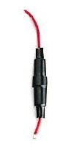
If you can get a couple of in-line fuse holders (see picture on right), then put fuses on some of the new wire links, as they originally had 10A fuses when they were in the S14/S15. Where a fuse should be added, I’ve put a Y in the ‘fuse column of the tables’. If multiple connections have to be spliced to one wire and all require fuses, just use one common 10A fuse for them all.

The ground connection to the ECU is provided by two ring terminals that bolt to the plenum. The plenum is then connected to the battery ground with the earth strap. Do not attempt to connect the loom to earth anywhere else, and do not connect the ECU without a proper ground connection. Likewise do not do any soldering with the ECU in place, or the battery connected.
Now we consider what wires from the S13 we extracted on page 3 are needed to join to the SR20 loom (via connector F4).
Here are the pinouts of the 4 plugs & wires extracted from the CA18 loom.

Take note of the numbers, they’ll be referred to later.
Connector F10
1: Neutral switch signal from gearbox
2: N/C
3 12V when Fuel Pump activated
4: 12V when aircon is activated
5: Signal wire to enable fuel pump
6:N/C
7:N/C
8:12V when ign on/start (via 10A fuse)

Connector F9
9: Signal wire to enable air-con Relay
10: CA18 Knock sensor shield
11: CA18 Knock sensor
12: N/C
13: N/C
14: Signal wire to enable ECCS relay
15: N/C
16: N/C

Connector F8
17: 12V from battery
18: N/C
19: N/C
20: ECU power (from ECCS relay)
21: To transistor pack
22: N/C
23: 12V when IGN on/start

Connector F1
24: Output from speedometer
25: Tachometer
26: Water temp gauge
27: Start 12V signal

Only the wires in bold need to be joined to the S13 loom.

The wires from the S13 ignition coil and ECCS relays won’t be used, as the SR20 loom has its own relays built-in (as you’ll notice when you have to unplug them to push it through the bulkhead).Therefore connector F9 is not needed. However, it was worth removing it from the S13 loom, just in case it is needed in future.
Join the wires from connectors F1,F8 and F10 from the CA18 loom to connector F4 on the SR20 loom, as in this table.

The first column, ‘Donor’ shows if a wiring join is applicable to your donor engine type
(e.g. only the S14 engine loom requires a wire join wiring for the CAS).
Where the donor is ‘ALL (14,14a,15)’. This means that different joins are needed at F4 for the different donors – e.g. 3,3,5 means join wire 3 for the S14 and 14a, but join wire 5 for the 15 SR20)
Donor | Connection | F4 (SR20) | Colour |  | Target on S13 | Colour |  | Fuse
All | ECCS Relay in | 32 | Red |  | 17 | red |  | Y
All | IGN coil relay/s'noids | 40 | Black/red |  | 23 | black/red
All | Start | 30 | orange |  | 27 | orange |  | Y
All (14,14a,15) | Tacho out | 3,3,5 |  |  | 25 | yellow/red
All (14,14a,15) | Speedo input | 5,5,12 | yellow/green |  | 24 | yellow/green
All (14,14a,15) | Neutral | 12,12,8 | green/orange |  | 1 | green/orange
14 | IGN ON/START | 48 | Black/red |  | 23 | black/red |  | Y
15 | IGN ON / INJ | 3 | blue/black |  | 23 | black/red
15 | Battery in | 32 | Red |  | 17 | red
14,14a | VTC, WG, Lambd | 29 | Black/red |  | 23 | black/red |  | Y
All | Fuel Pump | 22 | Black/yellow |  | 5 | Black/pink
14,14a | AAC | 31 | Black/yellow |  | 17 | red |  | Y
14 | CAS | 35 | Black/White |  | Join back to F4, pin 36
All | Dash Temp Gauge | 4 | Yellow |  | 26 | blue
Optional:
All | Diag Lamp | 28 | Orange |  | Bulb to 12V
All | Check | 19 | green/red |  | Consult board/plug
All | Consult RX | 8 | green/black |  | “
All | Consult TX | 18 | green |  | “
All | Consult Clock | 15 | green/white |  | “
All | Consult Ground | 10 | Black |  | “
All | Consult Power | 40 | Black/red |  | “
EGR (S14) |  | Slice off plugs and splice to F4 (contact me for more info)
BOOST (S14)

Additional Stuff (all engines)

Tachometer:
The signal to the tachometer needs a 10k ohm pull-up resistor to operate. You can do this at the ECU end (put the resistor between the tachometer pin on F4 and the IGN ON/START wire (which should be pin 40 on F4).
Alternatively pull out the tachometer and attach the resistor between the signal and ‘IGN’ screws on the back. If you happen to have a KA24 tachometer (e.g. you have fitted a 240sx digital dashboard), contact me as I’ve written up how to adapt these to CA18’s (easily), so all you do is add the 10k resistor to make them work with the SR20.

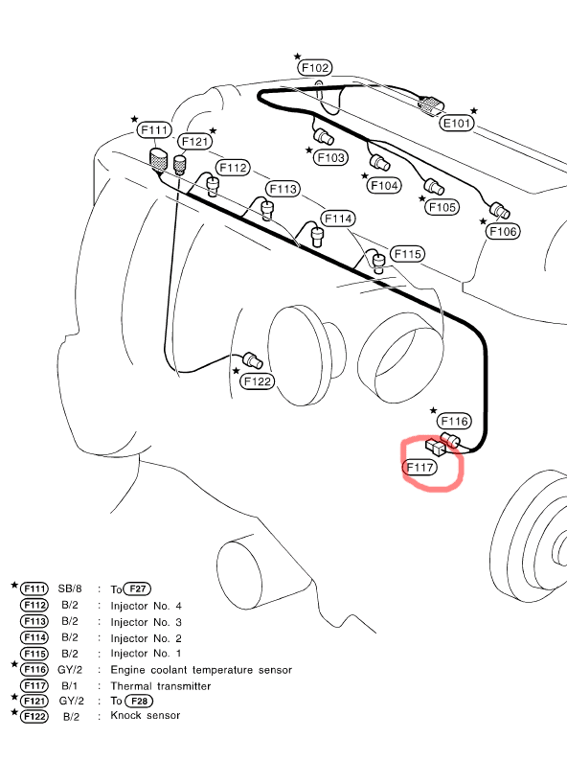
Water temperature gauge:
You’ll need to transfer your CA18 water temp sensor over to your SR20, as its resistance is matched to the gauge on the dash. The wires to splice are in the table, but to double check, measure the resistance between F4, pin 4 and the bodywork. It should be about 600 ohms when cold.

Speedometer:
You must fit the CA18 gearbox speed sensor to the SR20 gearbox to obtain a correct speed signal.

S15 owners need the S15 gauge cluster, ABS computer (part of ECU loom) and a rear diff with an ABS sender unit to get a speed signal (S13 ABS, S14 or S15 diff will provide a suitable signal). The ABS computer calculates the vehicle speed and tells the dashboard (which in turn tells the ECU for boost control, speed limiting etc).
The S15 ABS computer output speed signal is not compatible with S13 speedometers.

I have a home-made unit to allow you to drive an S13 speedometer (analogue or digital) from a differential with an ABS diff (no need to fit the S15 ABS computer). Contact me for details

Diagnostics lamp:
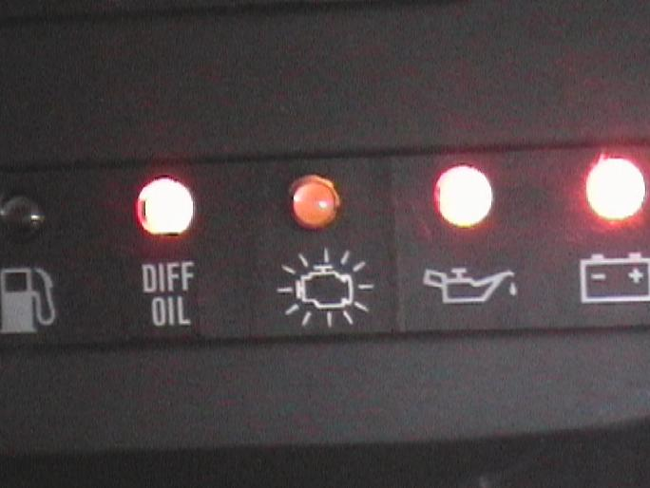
As in the NATS section, there is a driver in the ECU to operate a bulb to indicate electronic faults. Wire this to a spare bulb on the dash if you wish (one pin goes to the ECU pin, the other to 12V IGN signal). An LED could be used instead, with a 1k ohm resistor in series.
To put the light into diagnostics mode, wire a switch between 12V IGN and pin 23 on the check connector for S15/14a or pin 47 on S14. Shorting the pin to 12V for 2 seconds puts the LED into diagnostics mode.

Consult:
Wire a consult to RS-232 converter board to the pins on F4, listed in the pinout tables. S15 does not need a clock connection.
Testing

Before connecting the ECU, it is advisable to test your handywork.
Firstly, using the tables provided, check each wire you’ve spliced to exists on both F4 and the ECU connector (use a continuity test). This will help you check you’ve connected to the correct wires.

Put the multimeter on the current setting, put one probe on the body ground, and with the aid of a pin/needle, short-circuit any pins that operate relays to ground. You should hear a click from various places in all cases (or a whirring noise for the fuel-pump relay pin). The current may be up to 1 amp. The ignition may have to be on for this to work, depending on how it is wired. Also be aware of any aftermarket immobilizer you have fitted, as this may stop the fuel-pump from operating, unless it is disarmed. ECU relay is the most important to check.
You can check injectors with this method too, but leave this for troubleshooting if the engine refuses to start, as it’s unlikely they’ll not work as you shouldn’t have touched them when splicing looms..

Also use the multimeter (on voltage) to check all 12V connections work, and switch on/off depending on how the key is turned. Don’t forget to check the start signal (orange wire, number 27, page 6).

Check continuity between ECU ground pins and ground in the cabin.

You know an ECU is alive when you turn the key to IGN, and the ECU clicks on its ECU relay. If connected, the warning lamp (see previous page) will come on as a test, then go off when the key is turned to start.

PLEASE TAKE YOUR TIME doing the wiring. A blown ECU is not cheap to replace.

Future issues:

Air Conditioning. No plans to do this as I never had it anyway, and it’s just extra weight. If you really want it to work, contact me and I’ll have a think.

Load wires: give ECU additional feedback for regulating revs when defogger and headlights are on.

Mistake corrections: Bound to be a few – that’s why it helps if you understand what you’re doing.

Nicer pictures.

More re-jigging/rearranging/simplifying.

Any issues, or improvement suggestions, please tell me.
Fry1’s Mechanical guide:

Well seeing as there’s a few wondering what’s involved exactly, here is a little bit of what’s needed.
Right, I’m not going into every nut and bolt because if you have to worry about the tiny things then you should maybe consider getting some one else to do the swap for you.
Main parts you need:
Sr20det engine and gearbox ☺
S14 metal hot pipe from tubby
S13 accelerator cable bracket holder from plenum
S13 temp sender, single spade connector for dash temp display
S13 alternator/starter loom
S14 brass restrictor from fuel return pipe(not sure how essential this is)
S14 radiator and pipes
S14 heater hoses
Carrier for s14 ECU
S14 NATS 2: You want the NATS 2 ECU, immob. assy unit - which is a little black box located next to the ECU, the halo from around the ignition barrel, and the warning led from the dash, oh yeah - and the master key and any spares you can get
Matching loom, ECU and AFM, possibly CAS too.

If you’re using the older s14 loom to do away with NATS 2 (although the wiring is probably less complicated on the 14a loom) i.e. using an s14a engine and s14 wiring, get the loom, AFM, CAS, ECU, boost sensor, EGR (14a don’t have or need the latter two) from the s14. I have been told there are issues with mixing 14/14a CAS/AFM and ECUs, but if you get the lot from an engine that’s working then you should have no problems

Before you do anything, fit the alternator/starter wiring loom onto the SR, its much easier while its out, also slacken off the oil filter, either fit new before you put it in or replace once its in, its really not worth skimping on an oil filter, now is it?
The removal of the engine is straight forward, remove with gearbox as a complete unit.
Don’t forget to remove gear stick. Ideally hang from rope through front, turbo-side slinger and plenum Y-bracket.
Remove plastic trims in passenger side to gain access to ECU
Remove glove box and metal trim behind
I found it easier to remove the bolts holding in the fan and heater unit to give a little better access for pulling loom both in and out. You can’t remove it completely as there’s one up on top under the dash, just slack enough to pull away from the bulkhead - should be enough
Remove s13 ECU and engine loom. It’s easier to loosen off the ABS bracket to help in access to the big plug that seals the loom at the bulkhead, more for refitting than removal.
Loosen of the engine mounts on the sub frame. They’re on slots and slide up a little, which makes re-fitting the engine easier
The SR will fit onto S13 or S14 engine mounts. It will fit the same as if you were putting the CA18 and box back in. With the engine mounts loose it should be easier to drop the engine onto them, driver side first then passenger, there is more room on passenger side.
Bolt everything up, the s13 gearbox cross-member and propshaft fit straight on for S14 and S14a SR20 gearboxes. S15 6-speed box requires the splines of the S15 propshaft to be spliced onto the S13 propshaft. Get this at the universal joint, by a specialist (<£60).
Make sure you refit all earths, main earth to plenum, engine harness earths at rear of plenum, and small earth from rear of engine to bulkhead.
Swap over the temp sender on the SR for the for the CA one, same thread will fit straight in, if you don’t you wont get a reading on the interior gauge, it’s located down under the inlet to the plenum.
There was a little restrictor in the fuel return on the s14a parts I got, so I put it back in the fuel return on the s14, it was right in the end of the return pipe coming off the FPR - make sure you get supply and return the correct way round.
On fitting the loom be careful not to strip any wires on the bulkhead, make sure you get interior wires above the interior brackets for the heater unit, they will tuck nicely up into the top left of the foot well along with relays.
You can make or adapt the following:
The s13 power steering pipe bolts onto the s14pump, not in the original position and the locating pin no longer sits in the correct place but it does bolt up. Similarly, the CA18 PAS pump can be made to fit the SR20, with bracket modification, but this is not recommended due to skewed belt angle.
Make a carrier plate to bolt the s13 accelerator cable holder onto then bolt the lot onto the plenum.
S14 ECU housing can be used to bolt the ECU into the same holes as the s13 ECU- cut off the original brackets on the S14 carrier, straighten the bent one, and bend the long one at the end, so they match the ones on the s13 ECU, weld them back onto s14 ECU carrier.
S14 heater hoses are bigger, the S13 ones fit inside the S14 ones which then fit lovely back onto the s13 heater pipes coming out of the bulkhead, I cut off about 2” and inserted them inside s14 ones with a little fairy for lubrication (liquid that is). S15 heater hoses fit S13 bulkhead with a bit of waterproof tape to enlarge the outer diameter of the bulkhead pipes.
As a temporary measure I crossed over the original s13 WMIC pipes, which then were nearly a direct fit back onto the s14, only need alter the hot pipe from s14 to fit.
This is only to get it running I wouldn’t recommend extended use or high boost
The connector for the speed sender on the gear box was different so I just cut them off and joined them up, it doesn’t matter which way around it’s wired as it generates a pulse, - just make sure you get the right connectors, you will have 2 wires for reverse light switch, 2 for speed sender and 2 wires for neutral position switch.
If you use NATS 2, remove the passenger side air vent outlet on top of the dash, on the rear left hand side you will see a cut out for the NATS 2 warning LED which is the same as the one you have, cut out and push it in.
For S15 SR20 you can get away with cutting and rotating your standard exhaust. My stainless exhaust was too short to refit my S14 SR20, so a new downpipe was required.

